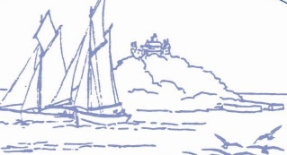
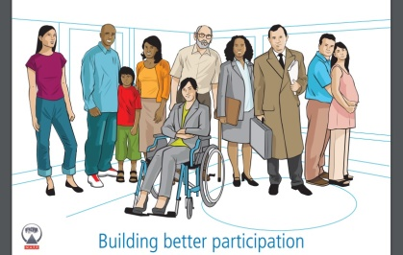
Marazion Surgery
Patient Participation Group

Minutes of the PPG Meeting on 15th May 2023

1. Minutes of Previous Meeting:

The Minutes of the previous meeting on 22nd March 2023 were agreed to be a true record.

2. Spring Raffle:

Raffle tickets were being sold and PPG members were reminded to bring in the stubs and payment, ready for the draw on 31st May. Volunteers were requested to help with the drawing of the raffle and contacting winners, late afternoon on Wednesday 31st May.

3. Information Workshop – Sleep – 19th June 2023 at 1830hrs:

Dr Herdman, GP Partner, had offered to do a presentation on sleep; ‘how sleep can affect your physical and mental health, what you can do to improve your sleep, and where you can be referred to for further help’. This would benefit many people of all different ages and presentations. The poster for the Sleep presentation on 19th June was circulated for members to display in local shops and venues, bearing in mind that this event was aimed at patients registered at Marazion Surgery. A copy would be attached to the Minutes.

PPG members were asked to arrive earlier, to welcome those who attended and provide refreshments. This was an opportunity for PPG members to tell people about the PPG and hopefully recruit new members.

4. Information Workshop – Diabetes – 12th July 2023:

A presentation by Mr Spencer Wimbleton, from Diabetes UK, had been arranged on 12th July 2023. Mrs Chloe Gendall, Practice Nurse, and Mrs Caroline Marchant, Social Prescriber would also attend. Juliette was due to meet with them later that week to formalise arrangements. A poster would then be devised and displayed around the surgery. This would be emailed to the PPG and copies would be made available for the PPG to collect from reception to display in the community.

5. Practical Support:

Juliette thanked members who helped with the car parking and selling raffle tickets at the recent Covid Spring Boosters clinic.

Some members expressed an interest in helping with the garden around the surgery, to improve appearances and attract local wildlife. Anyone who wished to be involved should let Juliette know, so she could pass on their details to Kim. Volunteers did not have to be PPG members.

6. Being Inclusive:

The group had been spreading the word about the PPG with a view to attracting new members, especially of younger age groups. There was a discussion on how best to publicise the PPG to younger age groups and how to engage with them about what they would like from their doctor’s surgery. There was a discussion about mental health and how it affected people in the community, including those in younger age groups. Suggestions on how to involve younger people included contacting local schools and clubs or doing a survey of different age groups registered at the surgery via text message. It was agreed that this could be looked at in September, after the summer.

Derek brought a copy of the ‘Turnpike’, a new newsletter that Marazion were circulating twice a year; it was agreed to include an article in the Autumn/Winter edition.

7. Terms of Reference:

The terms of reference were agreed.

8. Urgent Nurse Appointments:

It was suggested that the surgery should increase the number of appointments with nurses that could be booked on the day for acute exacerbations or flare ups (asthma was used as an example).

Two of the nursing team were due to go on maternity leave in July. New team members had been employed to cover this and were either already in place or due to start shortly. This had allowed an overlap for training on procedures and practice policies which would be very helpful. The PPG’s suggestion would be fed back to the Practice and considered as part of this period of change already happening.

It was also pointed out that if a patient was having any kind of medical issue that required urgent treatment, the receptionists should be made aware. If there were no nurse appointments available, advice from a nurse or a doctor would be sought.

9. Defibrillator Training for the Public:

Derek raised awareness of free CPR and defibrillator training that was being offered to the public by Cornwall Training & Consultancy. The poster is copied below, but local dates are:

25th May - Helston
27th May – Penzance
30th May – Penzance
3rd June – Helston
3rd June – Coverack
8th June –Constantine
8th June – Redruth
12th June - Goldsithney
17th June - Newlyn

10. Integrated Care Board (ICB):

Mick had previously attended ICB Meetings on behalf of the PPG, however since the pandemic he had been unable to attend. These were now held via Microsoft Teams. He provided the PPG with a copy of the latest minutes, should anyone wish to express an interest in attending on behalf of the PPG in the future.

For more information on this please contact Juliette.

11. Date of next meeting:

Wednesday 31st May – late afternoon – volunteers to draw the raffle and contact the winners.

Monday 19th June – Sleep presentation at 1830hrs (PPG to arrive earlier to greet attendees).

Wednesday 12th July – Diabetes presentation at 1830hrs (PPG to arrive earlier to greet attendees).

The next meeting of the PPG would be held in September 2023. Members would be contacted nearer the time to confirm availability.

If any issues arose in the meantime Juliette was happy to be contacted by Email; or arrange another meeting sooner than September if the PPG felt it appropriate.

Action List:

Sell raffle tickets (drop stubs and money into surgery once sold!) | Everyone
Promote Sleep presentation on 19th June | Everyone
Promote Diabetes presentation on 12th July | Everyone
Promote PPG in community | Everyone
Date of next meeting – September (date to be confirmed) | JCB

